Information Flow

We talk about information flow through a device. (Ex. Computer, Cell Phone, Robot, Remote Control) A device takes input and through processing turns that input, along with stored data, into output. 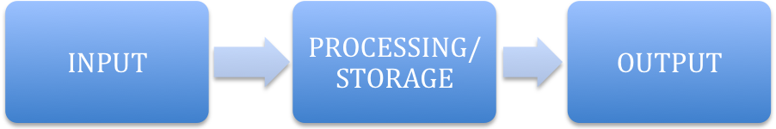

Input - Typing on keyboard, speaking into microphone, using game controller, etc.

Processing – Running programs, converting data files to music, etc.

Storage – Files or Data in Memory, Hard Drive, or other disk. (Ex. Music files stored on iPod memory, images stored on USB Drive, etc.)

Output – Sound (music) through speakers, video on monitor, infra-red signal coming out of remote control.